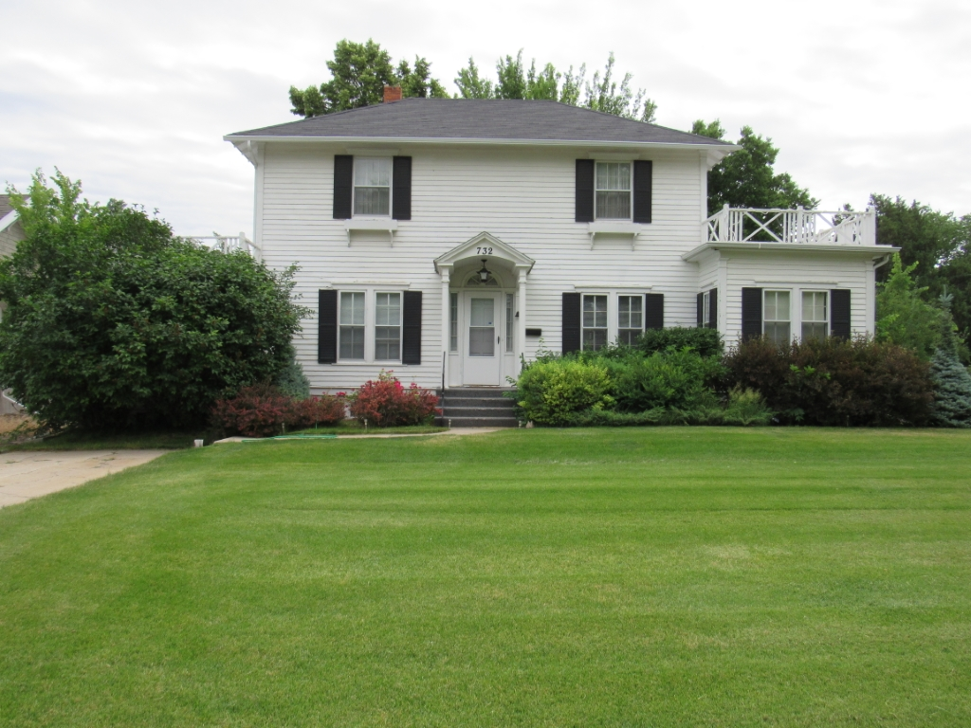
Year Built: 1920
Above Grade: 2,475 Sq Ft
Below Grade: 324 Sq Ft
Bedrooms: 4
Baths: 2 3/4

Lot Size: 66x150
Taxes: $3,021.04

Heat Type: Gas Forced Air
Cooling Type: Central Air

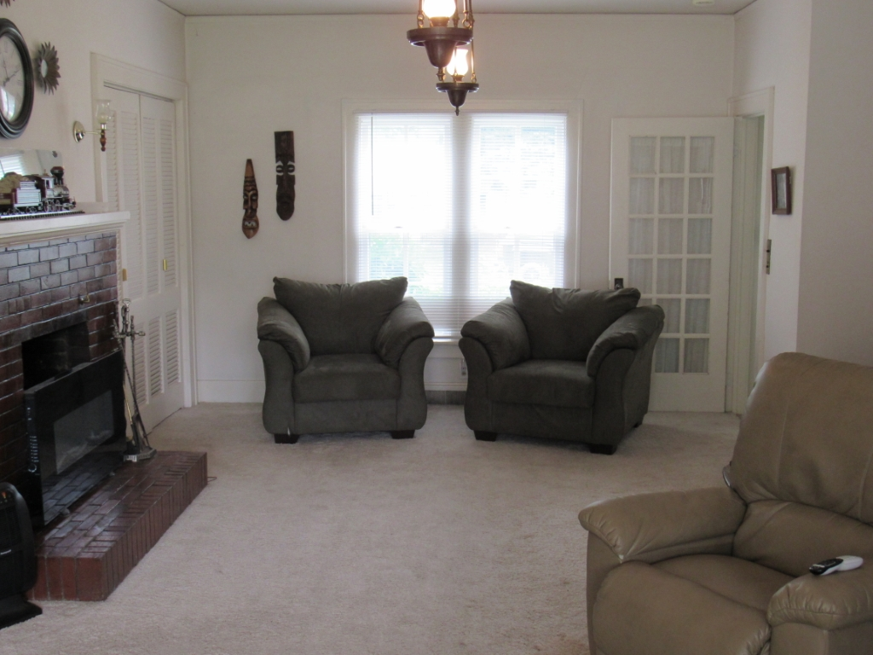

- Colonial Style Home
- Large Rooms
- Formal Dining
- New Roof, Furnace, & A/C
- Fenced yard
- Beautiful Landscaping

List Price $199,000

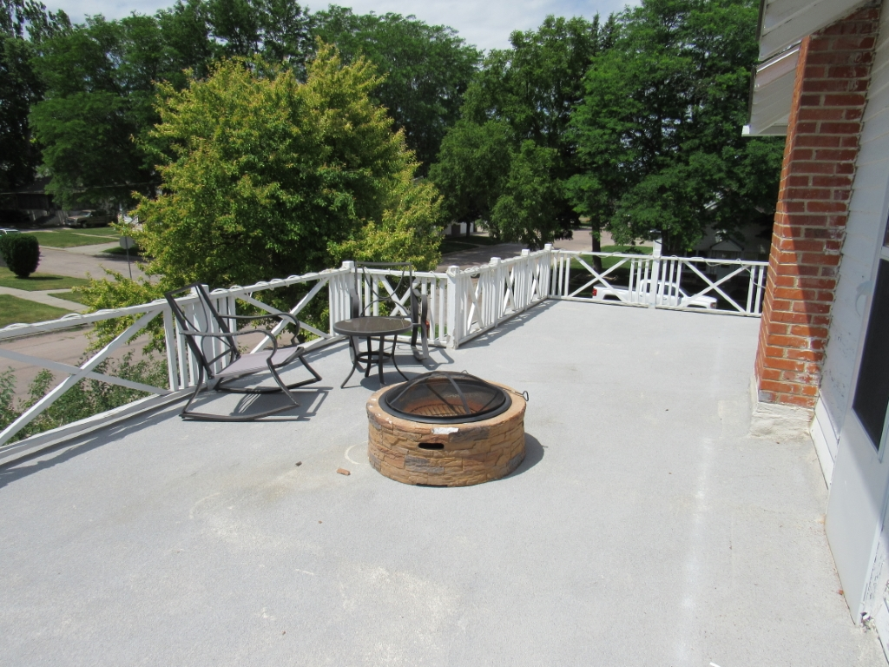



269 Main, Chadron, NE
(308) 432-6828
www.WesternViewRealEstate.com

Jessica@WesternViewRealEstate.com

Jessica Brueckner
Broker Associate
(308) 430-4094


